ΣC2600U
Digital Speaker Management Processor

Product Description:  The ΣC2600U is a 1U integrated speaker management processor. This device is easily programmable to meet all installation applications.  Key Features and Benefits:  - Integrated speaker management processor  - Three-way stereo or six-way mono crossover  - 32 bit floating point DSP and digital filter  - 2 x input XLRs + 6 x Output XLRs + 2 x RS485 XLR + USB + 1 x 6.5mm socket(BGM signal)  - Software programmable via PC (USB port)  - Provides input selection, gain control, delay, crossover, equalization and limiter functions  - DSP - 48kHz sample rate with 24bit AD/DA processing  - Front panel input and output LED indicators  - Store up to 20 presets  Front Panel:  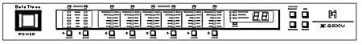  Rear Panel:  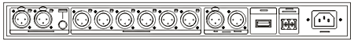
  Specifications
  Input Connector | 2 x Balanced XLR, 2 x RS485 XLR, 1 x USB + 1 x 6.5mm
  6 x Balanced XLR | 6 x Balanced XLR
  Output Connector | Balanced 10kΩ
  Maximum Output Levels | +20dBu
  A/D Sampling Frequency | 64kHz, 24bit linear
  Frequency Response (±0.3dB) | 20Hz-20kHz, 10Hz-30kHz
  THD + N | <0.006%
  S/N Ratio (A weight) | 110dB
  Dynamic Range | ≥ 110db
  Power Supply | 220V 50Hz
  Dimensions (W x D x H) | 483mm (19”) x 228mm (10”) x 45mm (1.8”)
  Net Weight (1 piece/pack) | 4.7kg (10.4lb)
  Gross Weight (1 piece/pack) | 6.3kg (13.9lb)
  Mouseover image to zoom
  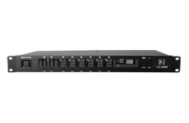
  Front View Back View

